MySQL Assignment 2 – Querying Data

Fathima minha .p
- Distinct Values:
⦿ a query to retrieve distinct salaries from the Employees table.
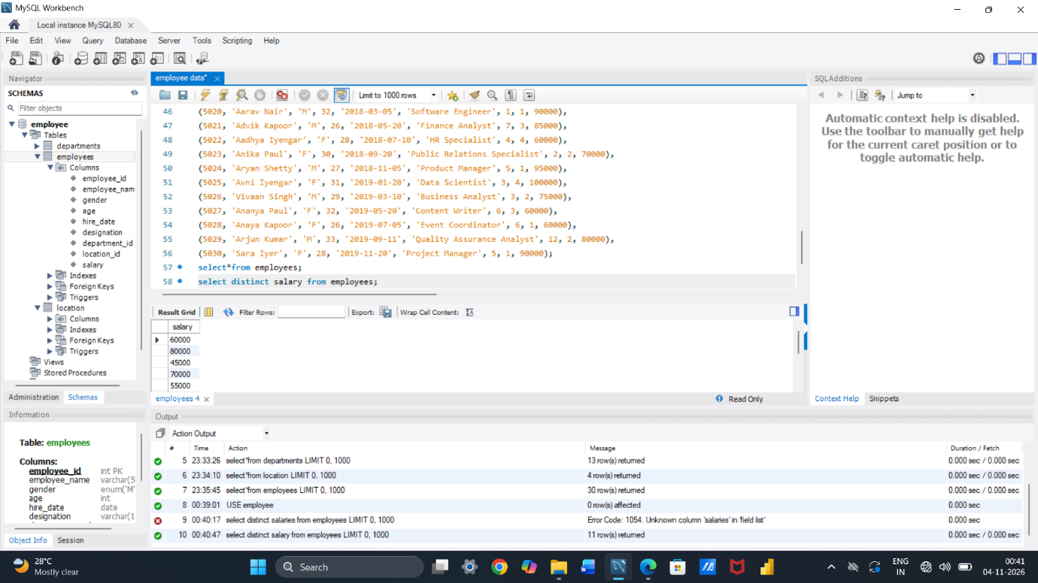
- Alias (AS):
⦿ Provide aliases for the "age" and "salary" columns as "Employee_Age" and "Employee_Salary", respectively.
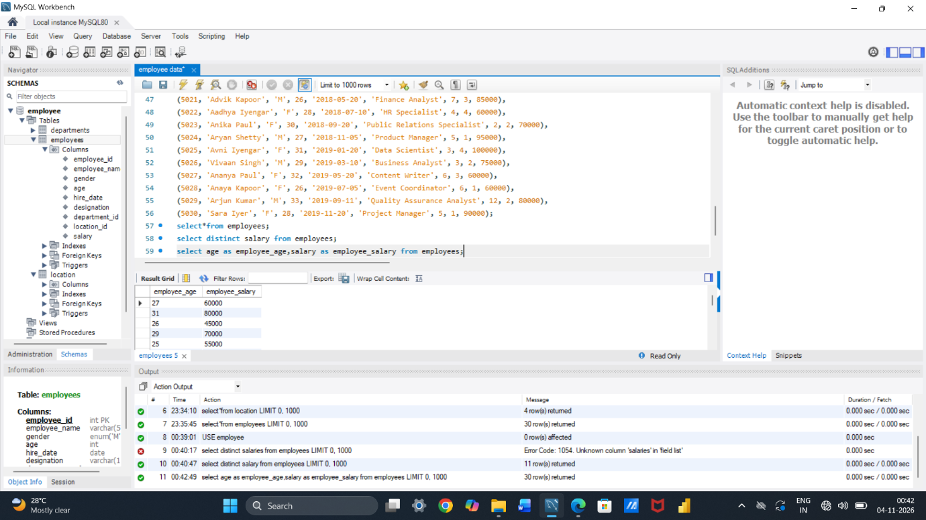
- Where Clause & Operators:
⦿ Retrieve employees with a salary greater than ₹50000 and hired before 2016-01-01.
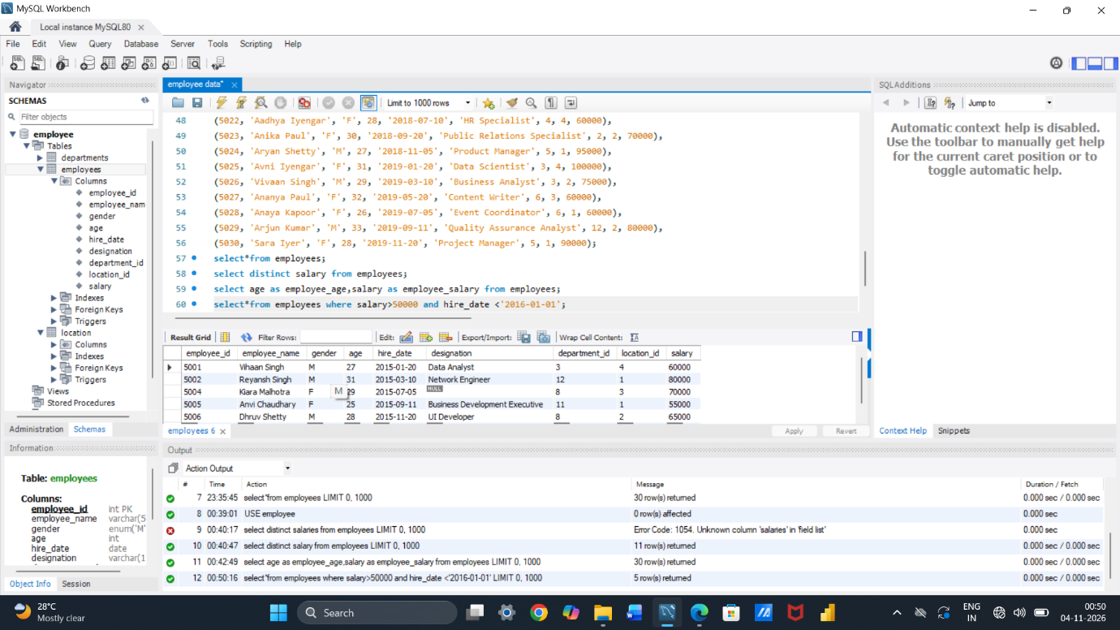
⦿ Find the employee whose designation is missing and fill it with "Data Scientist".
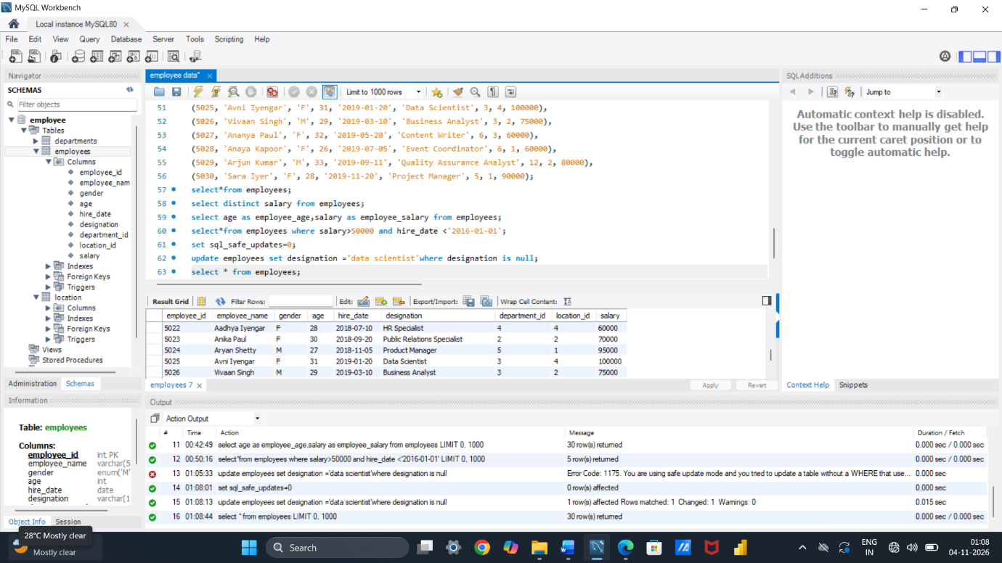

Sorting and Grouping Data:
- ORDER BY:
⦿ Find employees sorted by department ID in ascending order and salary in descending order.
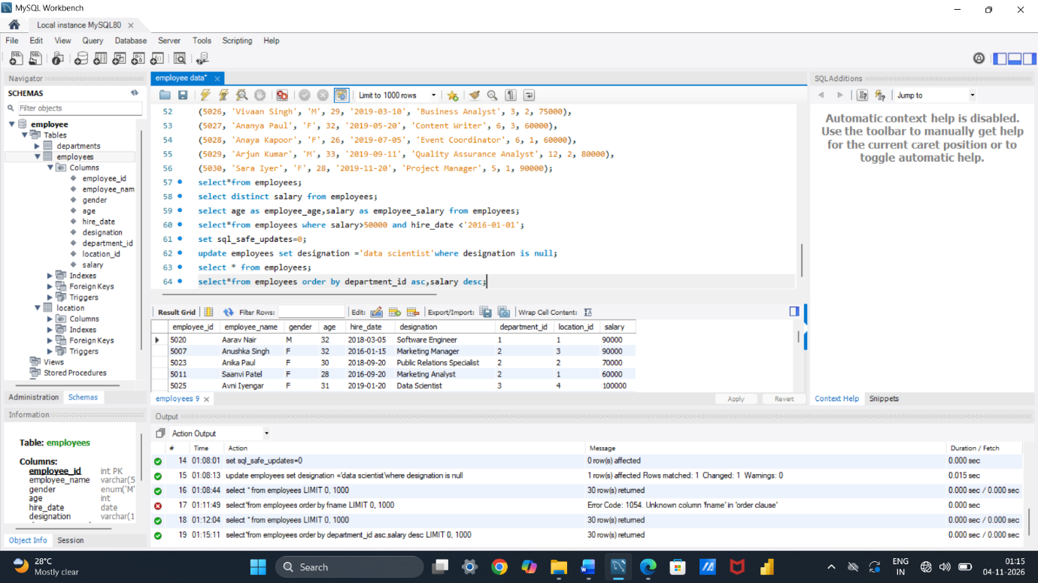

- LIMIT:
⦿ Display the first 5 employees hired in the year 2018.
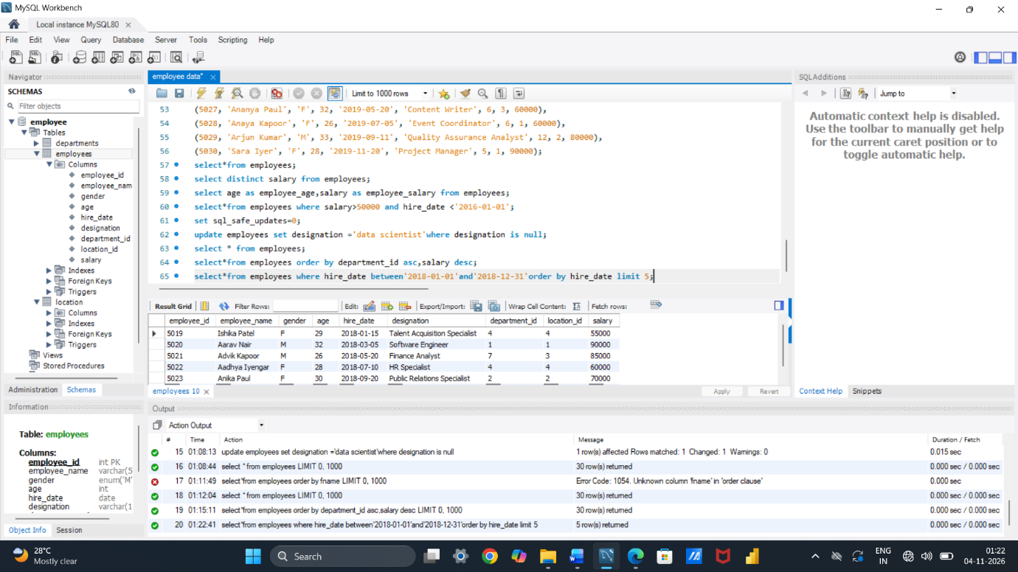

- Aggregate Functions:
⦿ Calculate the sum of all salaries in the Finance department.
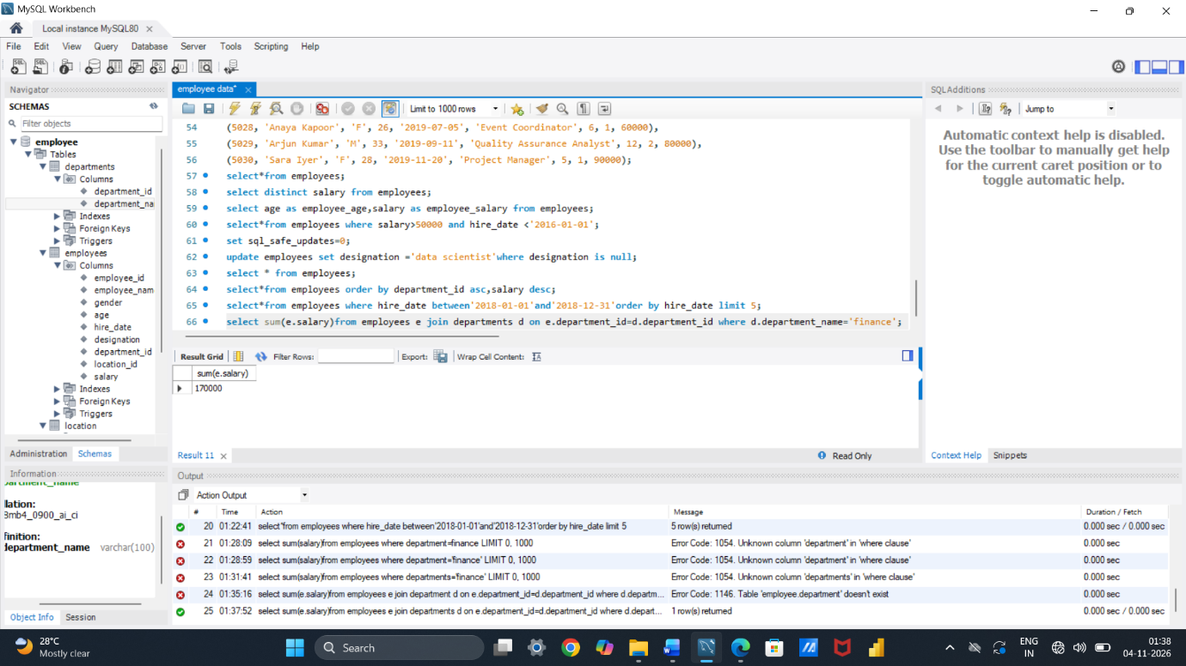
⦿ Find the minimum age among all employees.
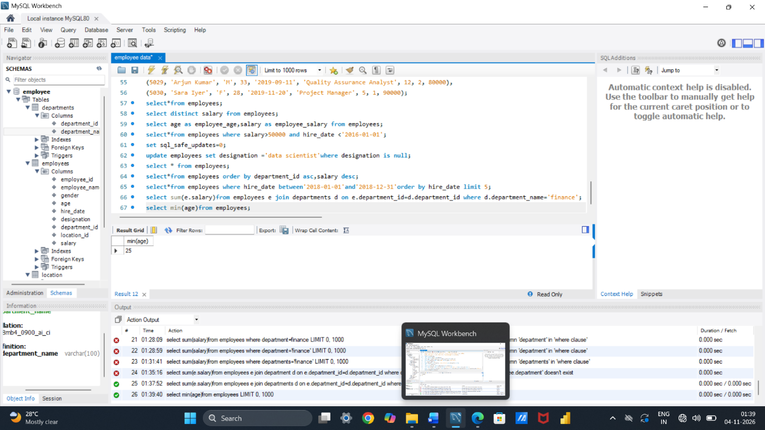

- GROUP BY:
⦿ List the maximum salary for each location.
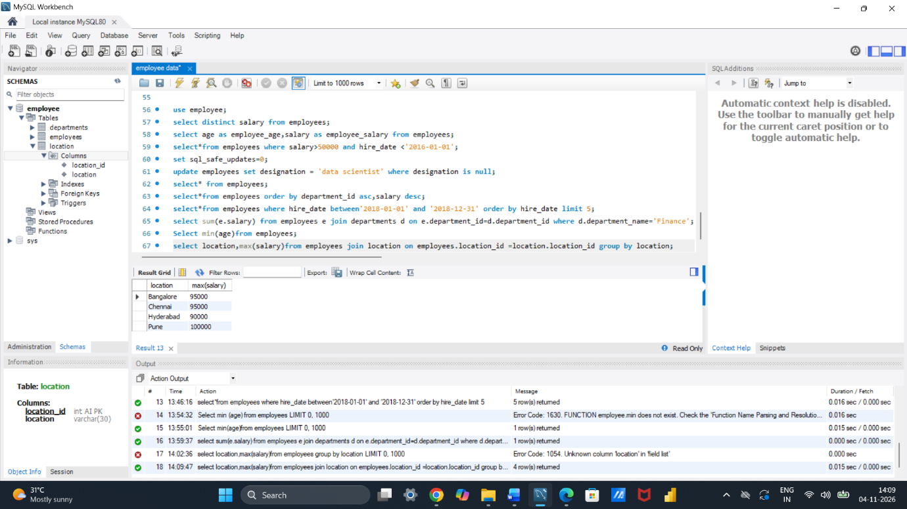
⦿ Calculate the average salary for each designation containing the word 'Analyst'.
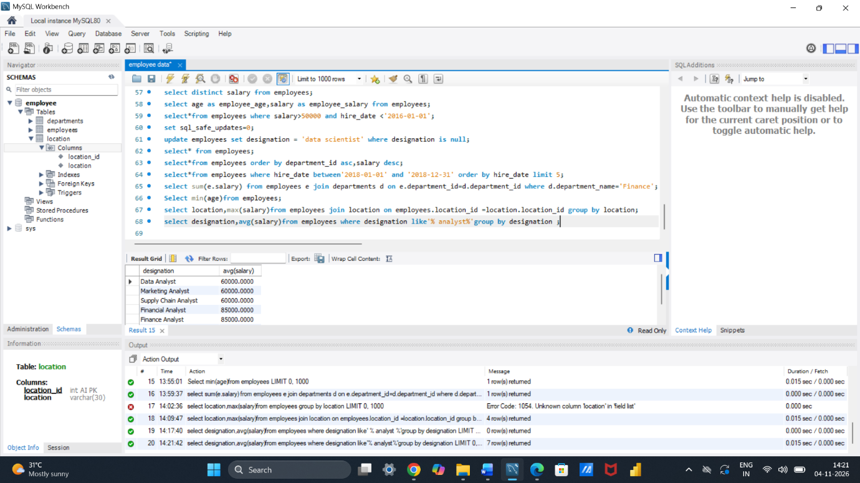
- HAVING:
⦿ Find departments with less than 3 employees.
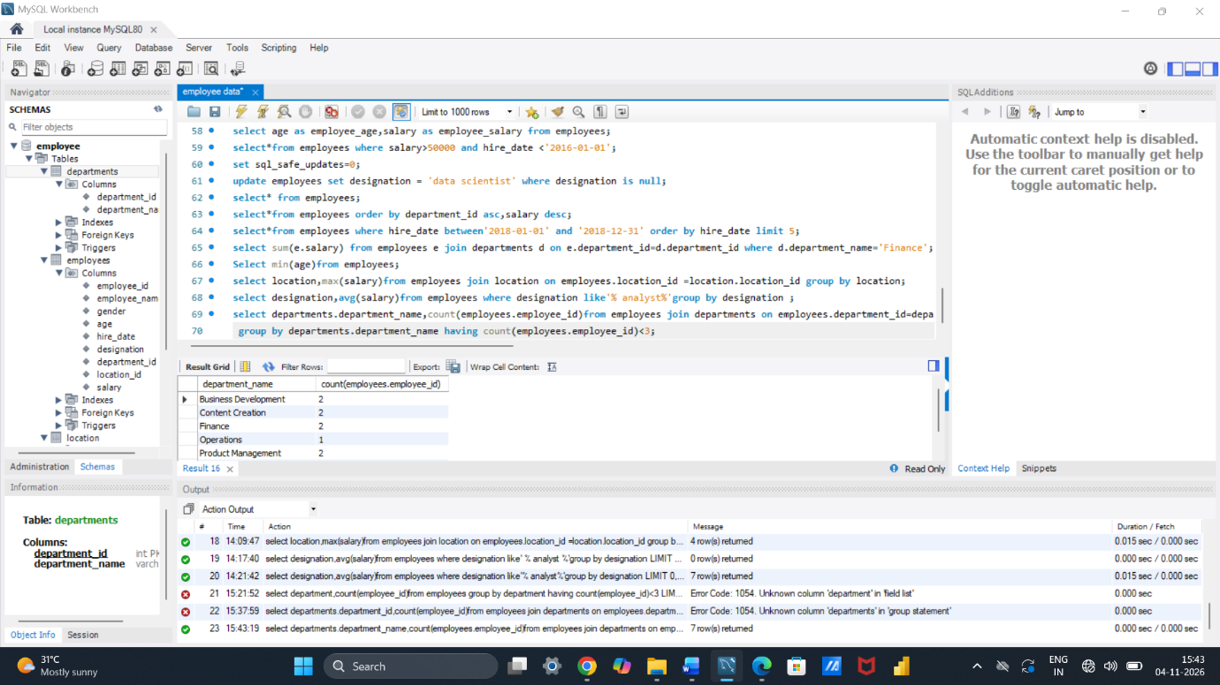
⦿ Find locations with female employees whose average age is below 30.
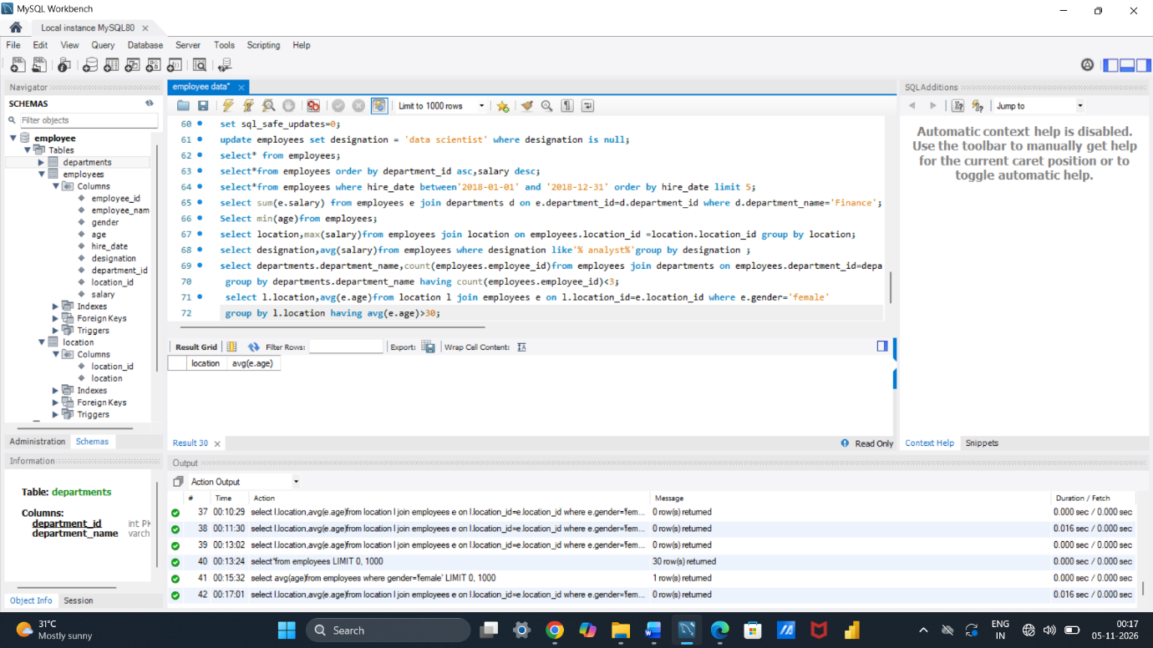

Joins: 1.
Inner Join:
⦿ List employee names, their designations, and department names where employees are assigned to a department.
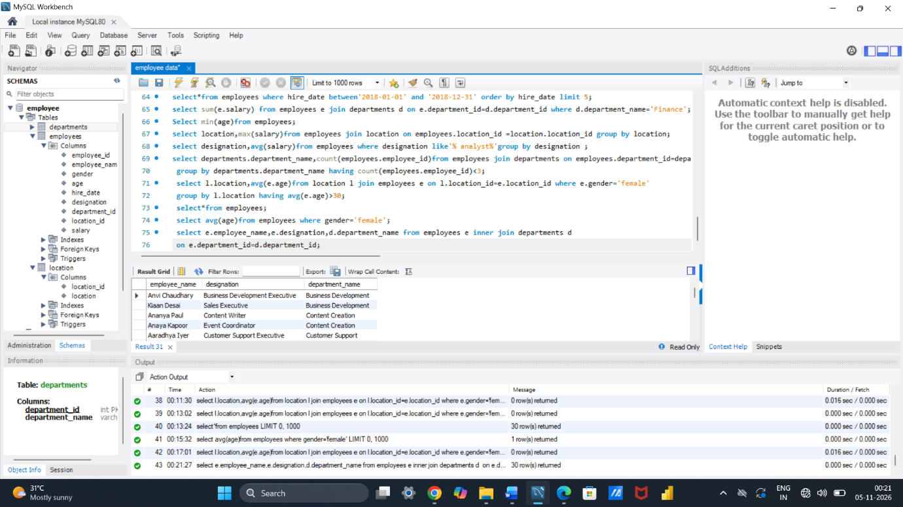
Left Join:
⦿ List all departments along with the total number of employees in each department, including departments with no employees.
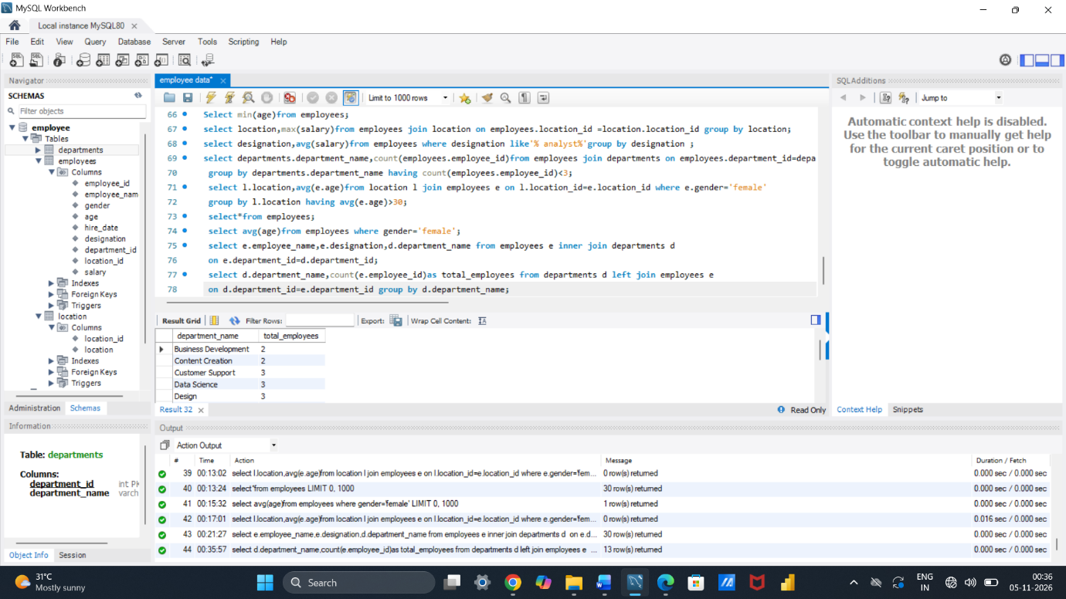

Right Join:

⦿ Display all locations along with the names of employees assigned to each location. If no employees are assigned to a location, display NULL for employee name.


